DATA STRUCTURES & ALGORITHMS (23CS4111)
ASSIGNMENT - SET 2
Problem-Solving and Thinking Ability - Programming Type
UNIT-I: Searching and Sorting

1.A company stores employee IDs in ascending order. Write a C program that accepts n employee IDs, searches for a required ID using Binary Search, displays its position when found, reports when it is absent, and counts the number of comparisons. Test the program for both successful and unsuccessful searches.

Source Code:
#include <stdio.h>

int main() {
int a[100], n, i, key, low, high, mid, pos, comparisons, choice;

printf("Enter number of employee IDs: ");
scanf("%d", &n);
printf("Enter %d employee IDs in ascending order:\n", n);
for (i = 0; i < n; i++)
scanf("%d", &a[i]);

do {
printf("\nEnter the employee ID to search: ");
scanf("%d", &key);

low = 0;
high = n - 1;
pos = -1;
comparisons = 0;

while (low <= high) {
mid = (low + high) / 2;
comparisons++;
if (a[mid] == key) {
pos = mid;
break;
} else if (key < a[mid])
high = mid - 1;
else
low = mid + 1;
}

if (pos != -1)
printf("Employee ID %d FOUND at position %d (index %d).\n", key, pos + 1, pos);
else
printf("Employee ID %d is NOT present in the list.\n", key);
printf("Number of comparisons = %d\n", comparisons);

printf("Search another ID? (1 = Yes, 0 = No): ");
scanf("%d", &choice);
} while (choice == 1);

return 0;
}

Output:
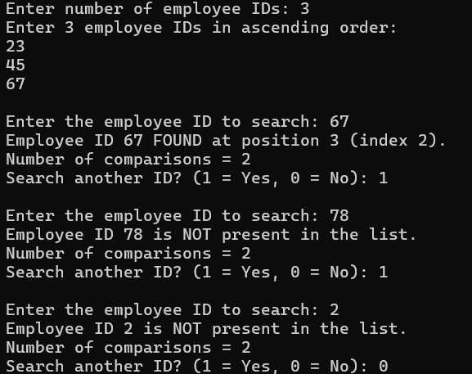

2.A teacher wants to arrange student marks in ascending order and also measure how much rearrangement is necessary. Write a C program using Insertion Sort that accepts n marks, displays the array after every pass, counts the total number of element shifts, and displays the final sorted list and shift count.

Source Code:
#include <stdio.h>

void printArray(int a[], int n) {
int i;
for (i = 0; i < n; i++)
printf("%d ", a[i]);
printf("\n");
}

int main() {
int a[100], n, i, j, key, shifts = 0, passShifts;

printf("Enter number of marks: ");
scanf("%d", &n);
printf("Enter %d marks:\n", n);
for (i = 0; i < n; i++)
scanf("%d", &a[i]);

printf("\nOriginal array: ");
printArray(a, n);
printf("\n");

for (i = 1; i < n; i++) {
key = a[i];
j = i - 1;
passShifts = 0;
while (j >= 0 && a[j] > key) {
a[j + 1] = a[j];
j--;
passShifts++;
shifts++;
}
a[j + 1] = key;
printf("Pass %d: ", i);
printArray(a, n);
printf(" (shifts in this pass = %d)\n", passShifts);
}

printf("\nFinal sorted list : ");
printArray(a, n);
printf("Total number of shifts = %d\n", shifts);
return 0;
}

Output:
